LONG AND SHORT
KS1 – 2003 Paper 1
1.
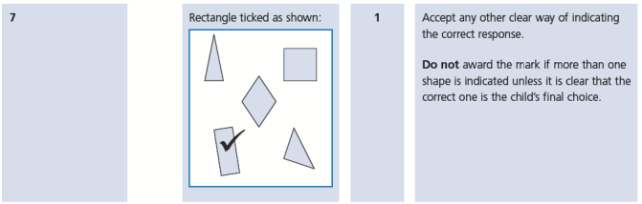
KS1 – 2003 Paper 2
2.
KS1 – 2009 Paper 1
3.
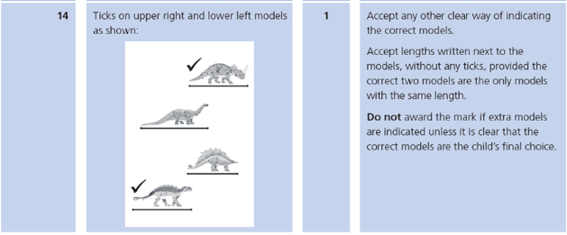

KS1 – 2018 Paper – Reasoning
4.
5.

